The team used the potentiostat to determine how effectively the materials could conduct current for water electrolysis. The list below shows each anode-cathode pair that was tested in the potentiostat.

* Nickel - Nickel
* Nickel - Stainless Steel
* Original Graphite (Pencil Lead) - Original Graphite
* Original Graphite - Stainless Steel
* New Graphite (pure graphite bars) - New Graphite
* New Graphite - Stainless Steel
* Platinum - Platinum
* Platinum - Stainless Steel

The potentiostat can only readout the current of each anode cathode pairing, but for our analysis, we wanted to see the current density of each pairing to normalize all our values by the surface area of the anode available for water electrolysis. To do this we simply divide the current by the anode’s surface area in solution. This surface area was calculated by marking on the anode where it touches the surface of the water. From there we measured both the length and diameter of the anode. In calculating the surface area, we assumed each anode was a perfect cylinder and made calculations with the standard areas of a cylinder. From these calculations, the results are depicted in the figure below.

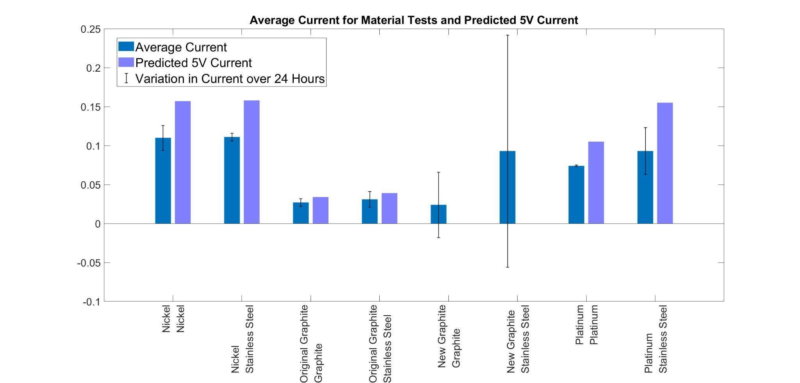

*Results of current density tests on material pairings with standard deviation noted as the error bars. Lighter bars indicate a predicted 5V current density*

In some of the findings, there is an additional value noting the “Predicted 5V current density.” Due to the potentiostat limitations, we could only read current up to 20mA, but some of our materials would reach higher values than that when a 5V voltage was applied. This would force us to reduce the voltage applied until the current reached back into a readable range. When the ion concentration, anode-cathode material, and anode-cathode distance are kept constant, however, we can assume that the resistance between the anode and cathode are equivalent and we can simply use Ohm’s law to determine what our results would have been at the 5V the Pioreactor will be supplying. These findings suggest that a nickel anode and stainless steel cathode outperform all other material pairings in current density, and exhibit low variation in current over time. While we would expect the platinum to perform the best, an interesting phenomena occurs on the surface of the nickel that may be allowing higher currents. The team, after consultation with chemistry professors, believes the nickel is reacting to form a specific nickel oxide that is improving the current density. While fouling usually impedes the current, the nickel tests will generally increase in current over the 24 hours of testing, pointing to the fouling being a conductive material as well.

Another factor considered for our anode analysis is the fouling that forms on the surface of each anode. Fouling is the buildup of material on the surface of the anode that is unwanted as it reduces the available surface area on the anode and reduces its ability to perform electrolysis. From our testing with the potentiostat, there are significant fouling issues with nickel and slight issues with the graphite. As seen below, fouling is present in nickel.

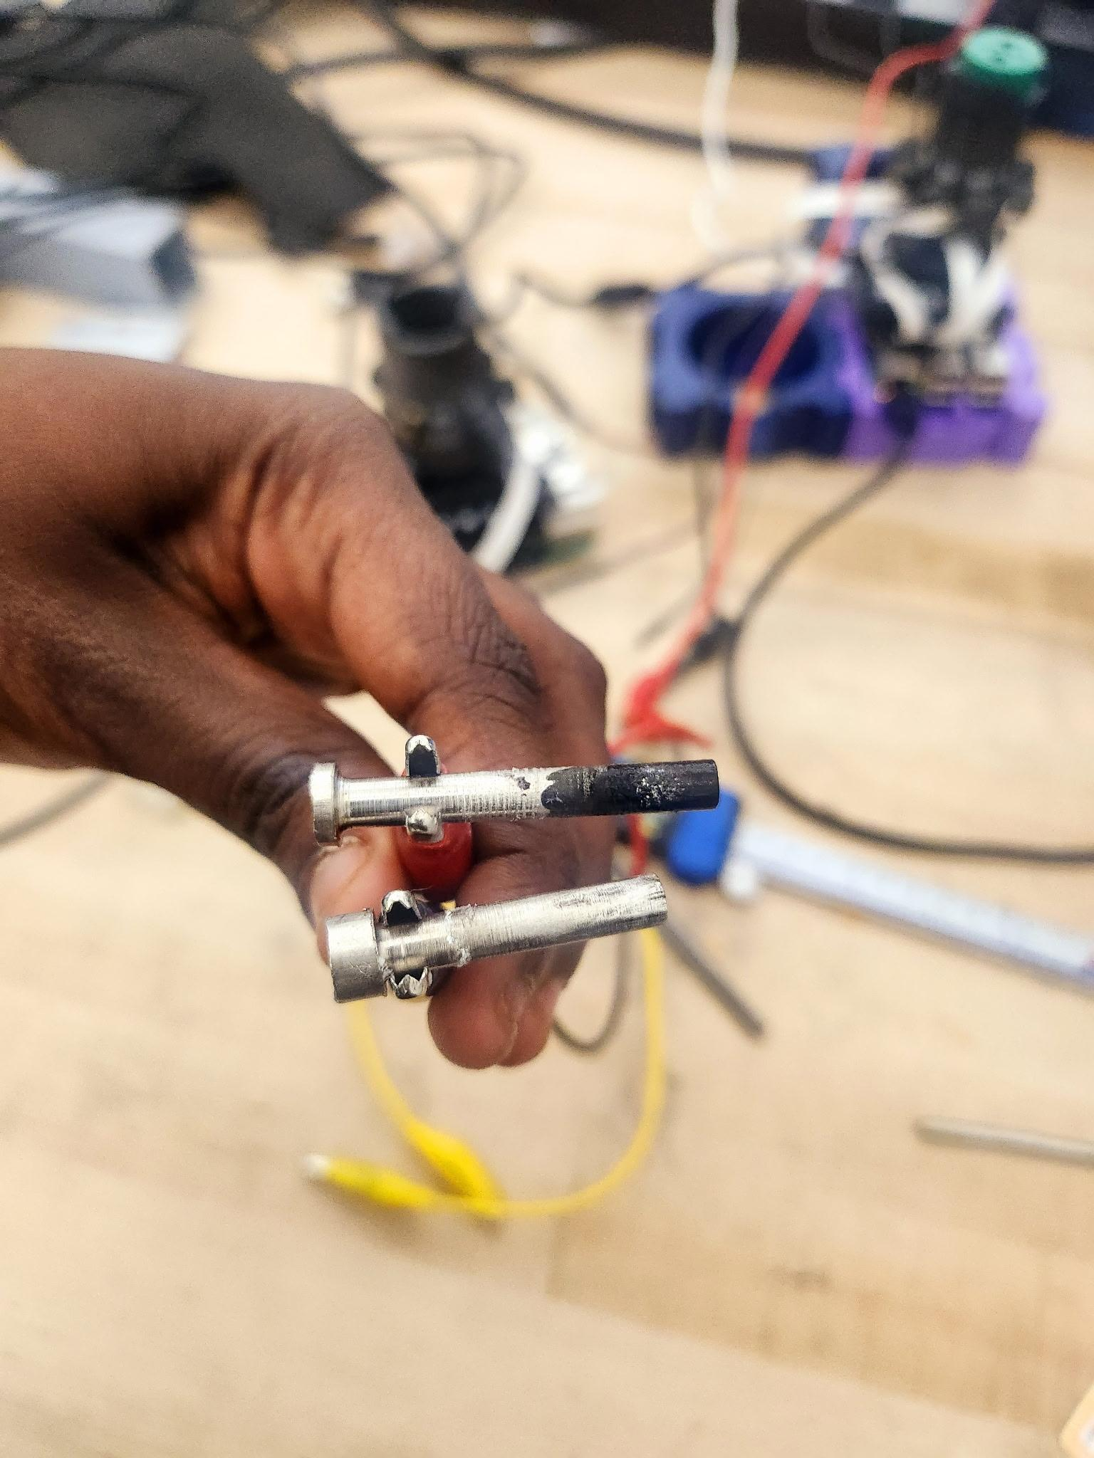

*Visible fouling from Nickel Tests*

The fouling that coats the nickel does not appear to be rust. The inky-black color to the substance and current increase seems to indicate there is another material forming. While there is little fouling in the case of pure graphite, there was a large amount of debris in solution from the graphite breaking off. Since this was much higher than the pencil graphite and the bar chart shows very little improvement between the two materials, further testing was not pursued with the pure graphite rods.

After understanding the current density of each material, we wanted to ensure that these materials support bacterial growth properly. While nickel-stainless steel has the highest current density, there may potentially be other factors that stunt the growth of bacteria and must be tested before that material can be selected as the best material for our use case. To test this, we use the optical density that the Pioreactor has onboard its system. Using the pioreactor, we can collect optical density data that tells us how much stuff we have in solution. Assuming all contamination measures were taken, the only substance we should have in solution is debris from the anode and HOBs. We account for the debris in solution by recording optical density measurements of our anode-cathode pairs without HOBs in solution. This gives us a baseline optical density including the debris that forms from our anode and can then be compared to our bacterial findings. The bacterial findings are below, while control tests are at the bottom of the document.

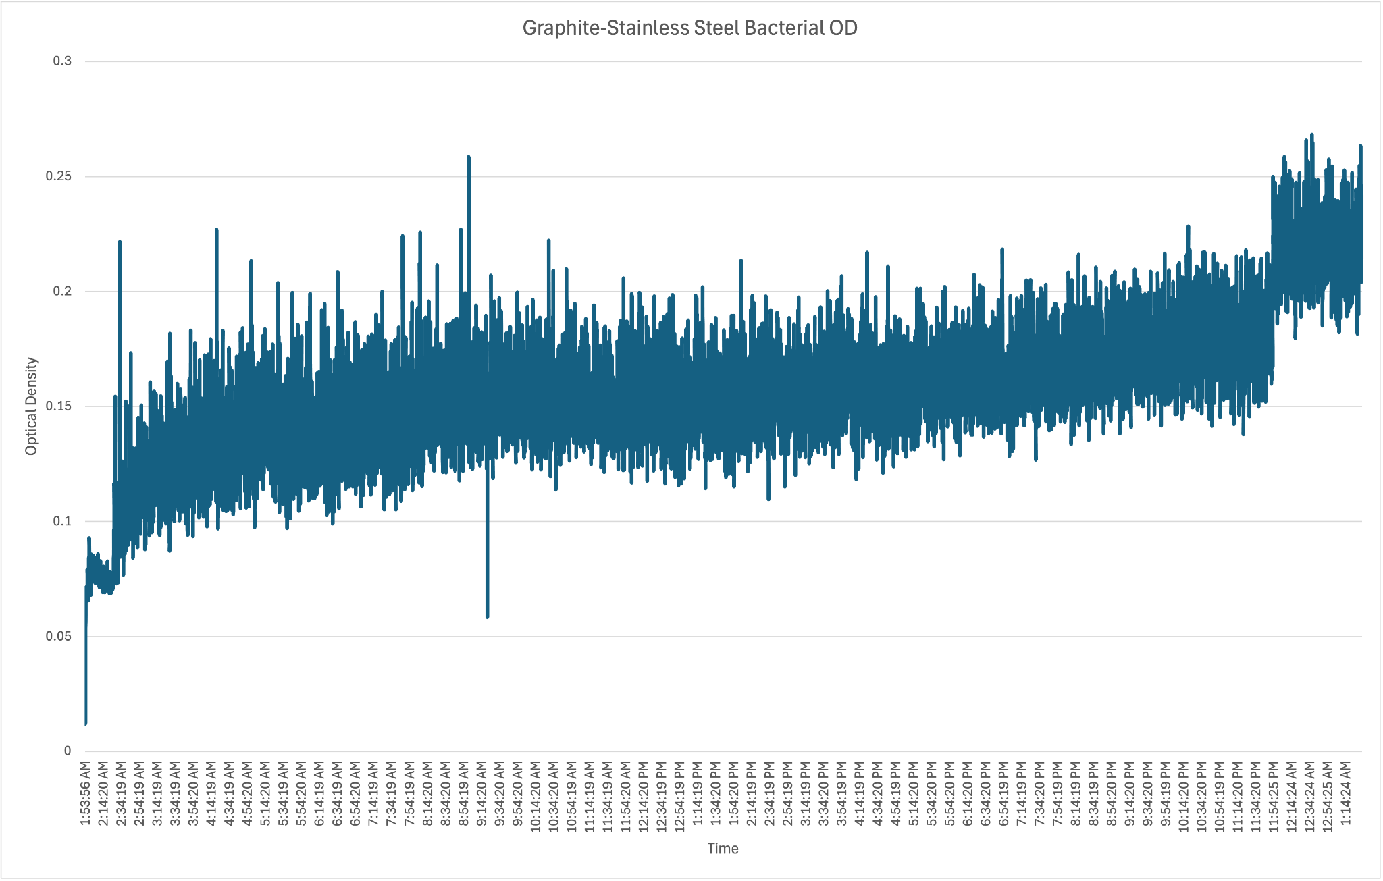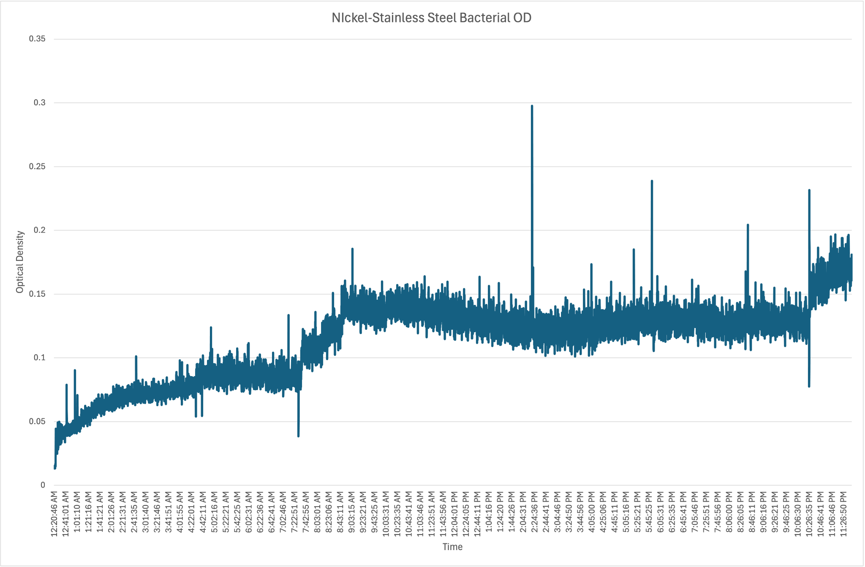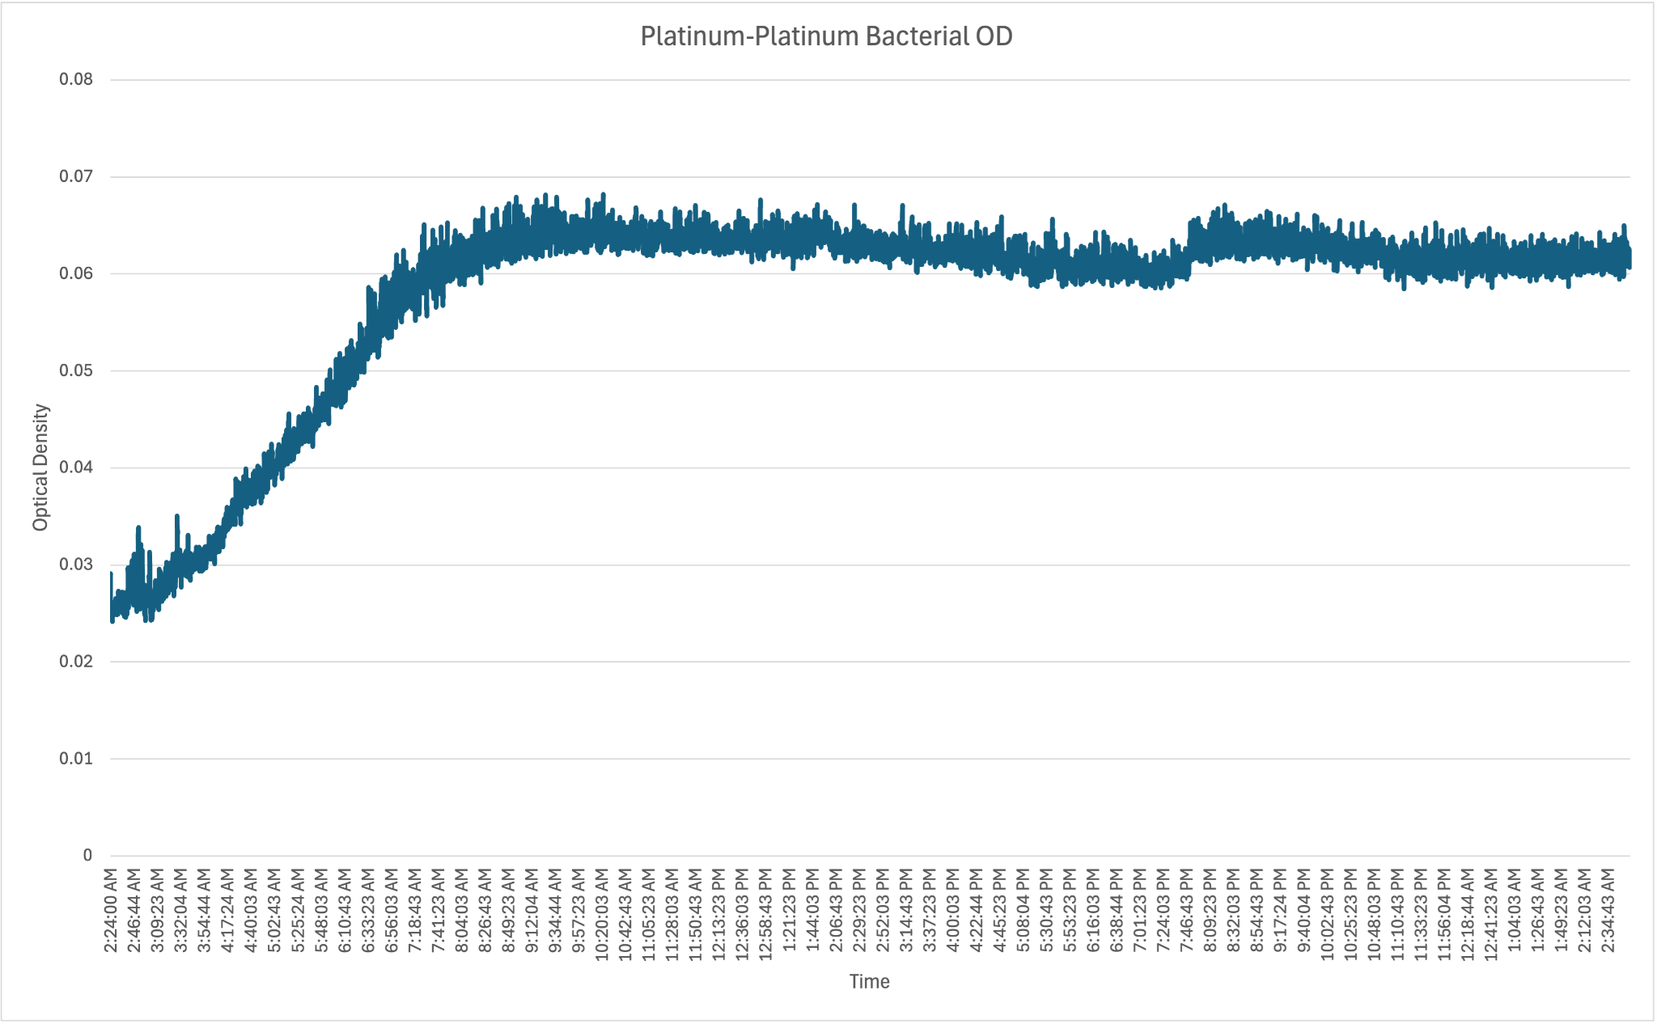

*Optical density measurements for material pairings with bacteria in solution*

To compare these results, it is more beneficial to pay attention to the rate of change of optical density between tests. From these results we can conclude that platinum-platinum has the highest optical density overall. While we currently have platinum-platinum selected as the best for optical density, it is important to compare these optical density results to those without bacteria. This allows for a better understanding of the rate of bacteria growth from the rate of change in optical density. From these results we can get a better understanding of what material promotes the most bacterial growth. In looking at the control data in Appendix D, we see that the nickel control test yields unrealistically high optical density readings for the control test that are not represented in the bacterial test. These values are attributed to the inky black substance that was formed by nickel. If this material were large enough to pass in front of the sensor, it would lead to data points that do not reflect the rest of the solution. This will need to be further investigated before we can make any claims about the best material to replace platinum in the system with full confidence. Additionally, bacterial growth curves were generated and are shown below. The growth rate, which is based on the optical density measurements, show that nickel is nearly as efficient in their ability to grow bacteria in solution as platinum plated titanium.

**Future Recommendations**

During testing with the potentiostat, metallic debris and fouling was observed in the solution. The anode subteam recommends further investigation into the composition of this debris to determine whether it is food-safe and to assess its overall impact on the current density performance. If the debris is found to be a contaminant, a standardized process for its removal should be explored. This includes assessing potential filtration methods that are specifically designed to target and remove the identified debris particles as well as an analysis on lower voltage in reducing the falloff while maintaining acceptable bacteria growth. Important considerations for filtration should include product availability, cost-effectiveness, and the ability to maintain solution quality.

Additionally, we recommend conducting further designing to find methods to increase surface area while achieving all other material objectives. This would involve researching easily manufacturable ways to increase surface area as well as considering how these designs may promote or prevent fouling on the surface of the anode.

Finally, in anticipation of commercial scaling, we suggest a thorough evaluation of the feasibility of electroplating the selected material combinations. This evaluation should consider the environmental impact of the process, health and safety risks to workers, the need for rigorous quality control of the metal finishes, and effective waste management strategies. Additionally, the high cost associated with sustainable electroplating methods may deter potential investors.

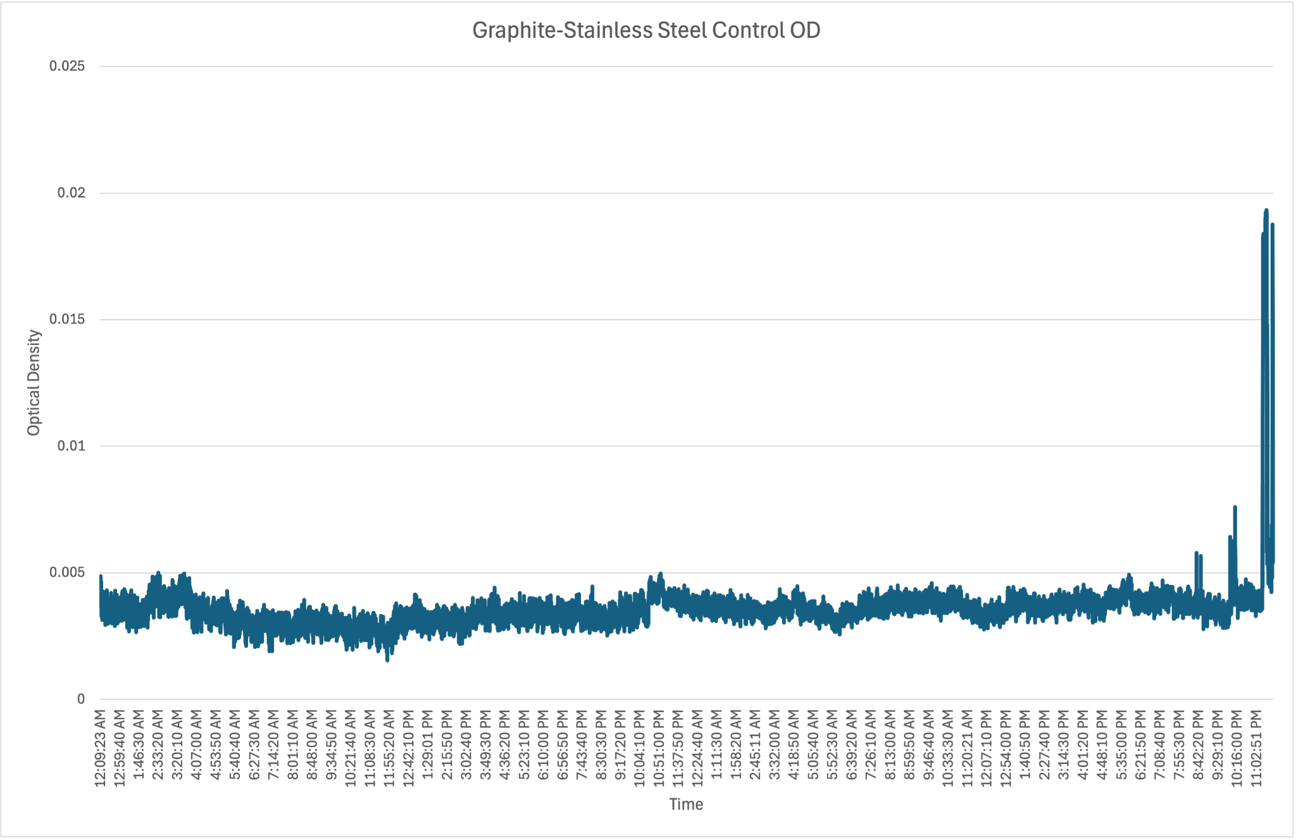

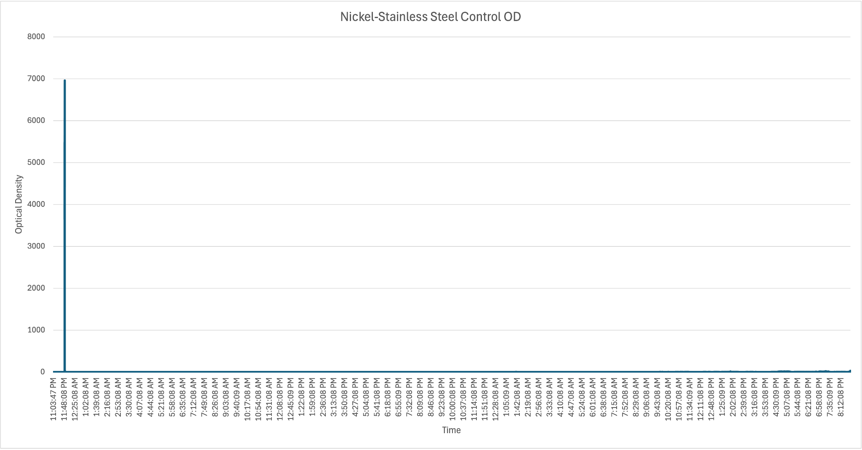

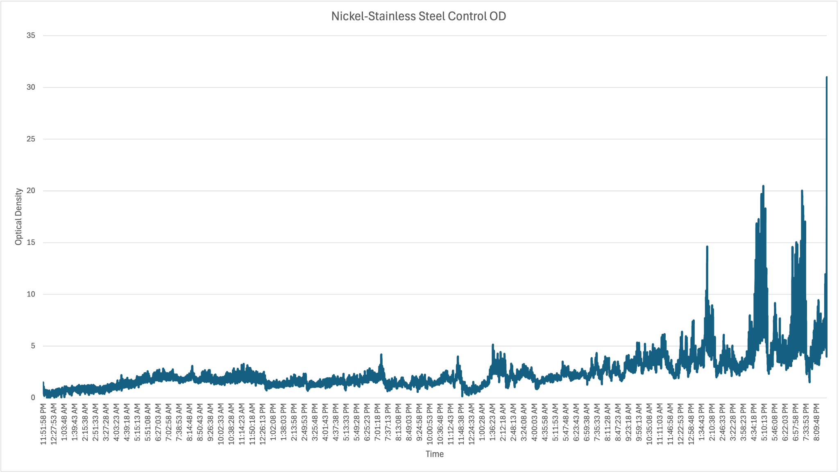

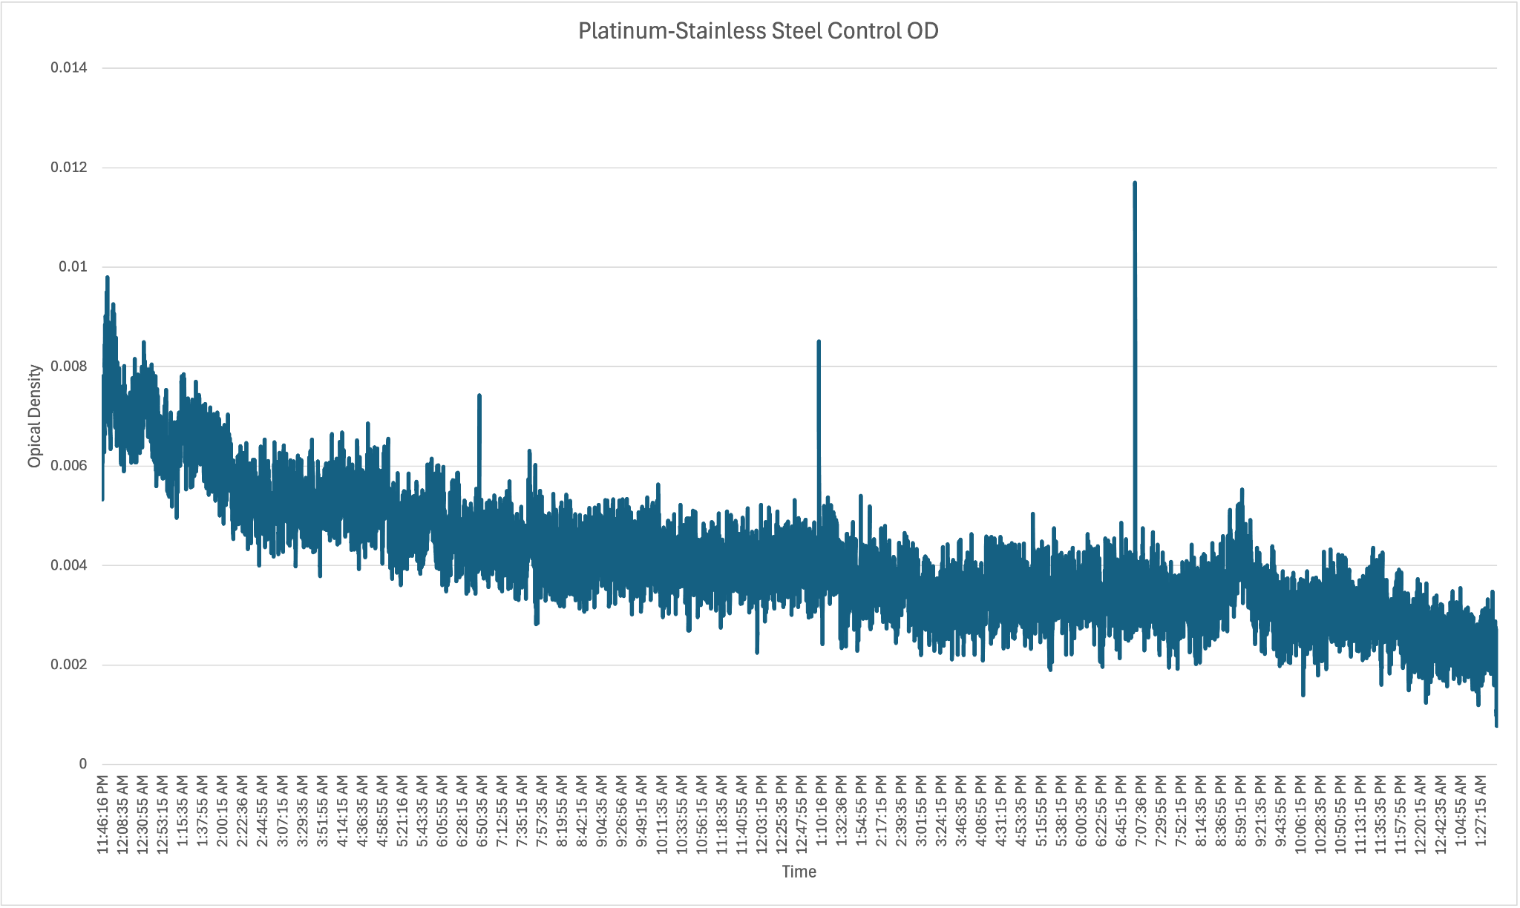

*Control data for anode-cathode tests*

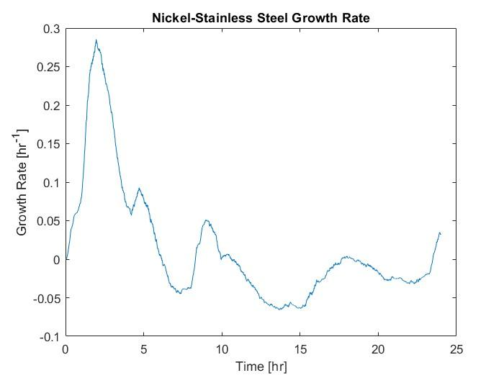

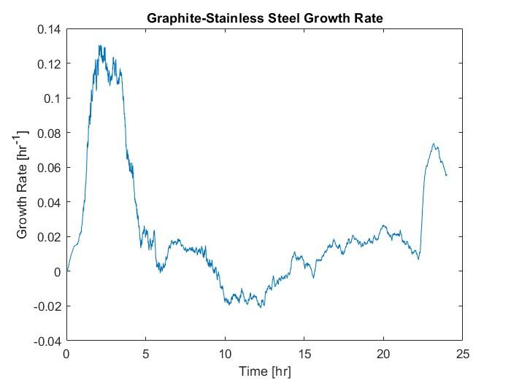

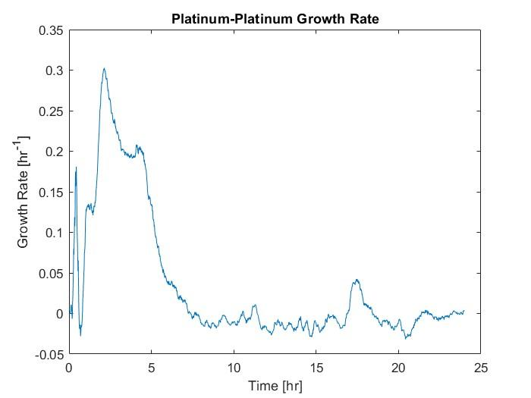

*Growth curves for anode-cathode tests*